

Form 10-10EZ  
Health Benefits Update (Digitization)

Version 2

Launch: April 11, 2024

Table of Contents

Overview and Navigation

Introduction Page

Signed-in Users: LOA1 (Not Identity Verified)

Signed-in Users: LOA3 (Identity Verified)

Filling Out the Form

Veteran Information

Step 1 of 5: Names  
 Authenticated User

Step 1 of 5: Mailing Address

Step 1 of 5: Phone and Email

Military Service

Step 2 of 5: Military Status

Military Service: Page 1

Military service page 2: Cleanup or response efforts

Military service page 3: Service in Gulf War locations

Military service page 4: Service dates for Gulf War locations  
Military service page 5: Operations

Military service page 6: Agent Orange locations

Military service page 7: Other toxic exposures

Military service page 8: Other unlisted toxic exposure

Military service page 9: Dates of exposure

Household Information

Step 3 of 5: Marital status

Step 3 of 5: Spouse’s personal information

Step 3 of 5: Spouse’s additional information

Step 3 of 5: Spouse’s financial support

Step 3 of 5: Dependent’s information

Step 3 of 5: Dependent’s personal information

Step 3 of 5: Dependent’s education expenses

Step 3 of 5: Dependent’s additional information

Step 3 of 5: Dependent’s annual income (previous year)

Review Your Dependents

Step 3 of 5: Annual income

Step 3 of 5: Previous calendar year deductible expenses

Insurance Information

Step 4 of 5: Medicaid

Step 4 of 5: Medicare

Step 4 of 5: Medicare detail

Step 4 of 5: Other coverage

Step 5 of 5: Review

Health Benefits Update Form Troubleshooting

Questions About the Content of the Form

The Form is Pre-filled With Incorrect Information

Veteran Can’t Move Forward in Their Form

The Veteran is Having Trouble Upgrading From LOA1 to LOA3

# Overview and Navigation

VA.gov users can update their health care benefits information by filling out the online VA Form 10-10EZR, the Health Benefits Updates Form. Users with an LOA1 account (not identity verified) or an LOA3 account (identity verified) can access and complete the Health Benefits Update Form.

A user can find the Health Benefits Update Form at <https://www.va.gov/health-care/update-health-information> or

* On the VA.gov VA health care page at [www.va.gov/health-care](http://www.va.gov/)

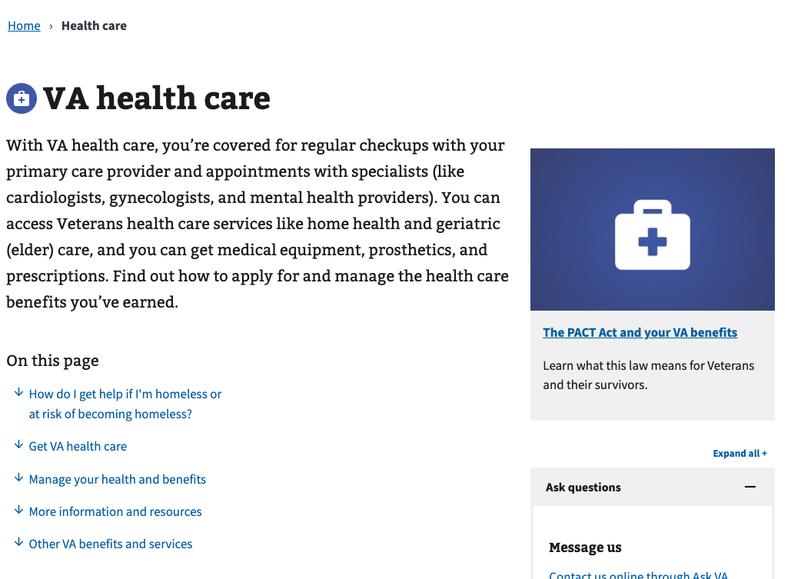

* In the VA health care benefit hub: <https://www.va.gov/health-care/>

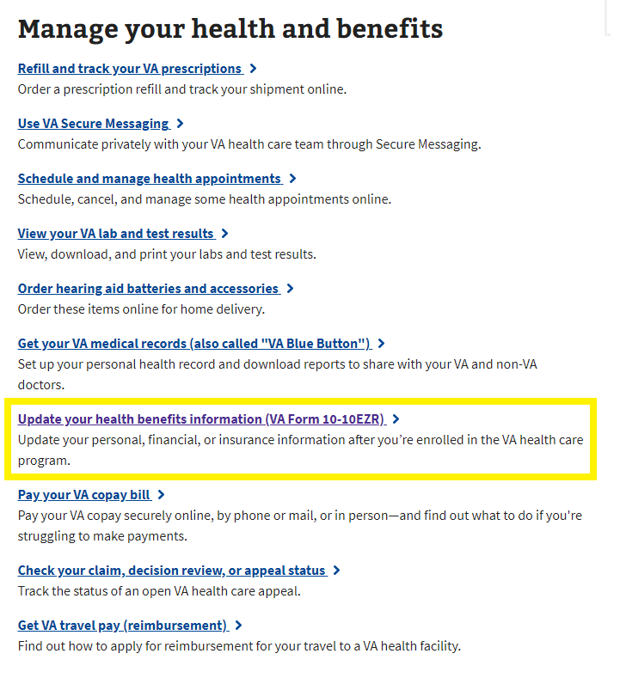

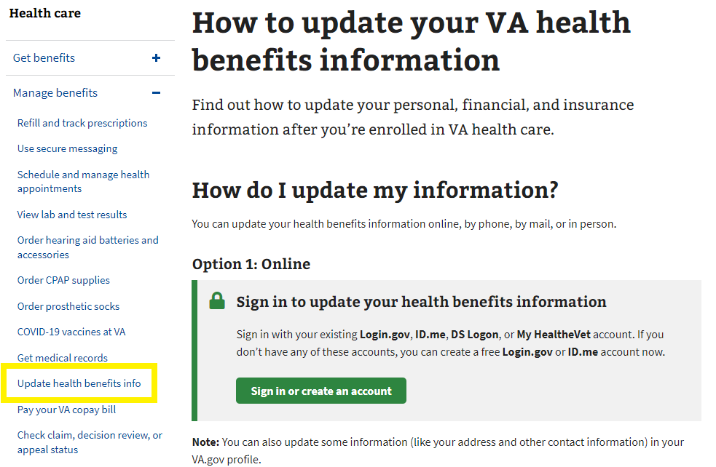

* In the My HealtheVet hub: <https://www.va.gov/my-health/>

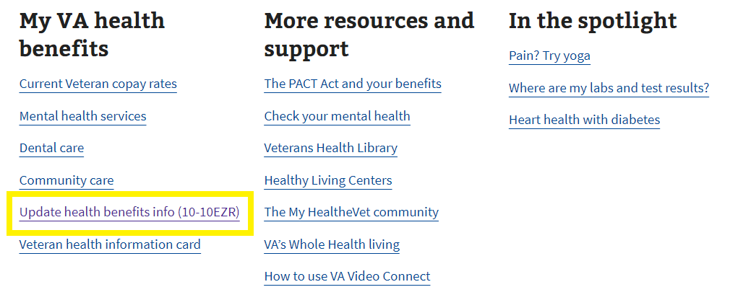

# Introduction Page

Currently, the Update Health Benefits form is available on VA.gov (<https://www.va.gov/my-health/update-benefits-information-form-10-10ezr/introduction>) to signed-in users who come to the site and are enrolled in VA health care, whether they are LOA1 or LOA3.

Unauthenticated users will be prompted to sign in to update their information online.

## 

## Signed-in Users: LOA1 (Not Identity Verified)

Signed-in LOA1 users will see the following alert when they visit the Health Benefits Update Form introduction page at <https://www.va.gov/my-health/update-benefits-information-form-10-10ezr/introduction>. LOA1 users won’t be able to access the Health Benefits Update Form without first verifying their identity and becoming LOA3. This identification process ensures that all users who apply are scanned through the ESR to confirm whether they are enrolled in VA health care.

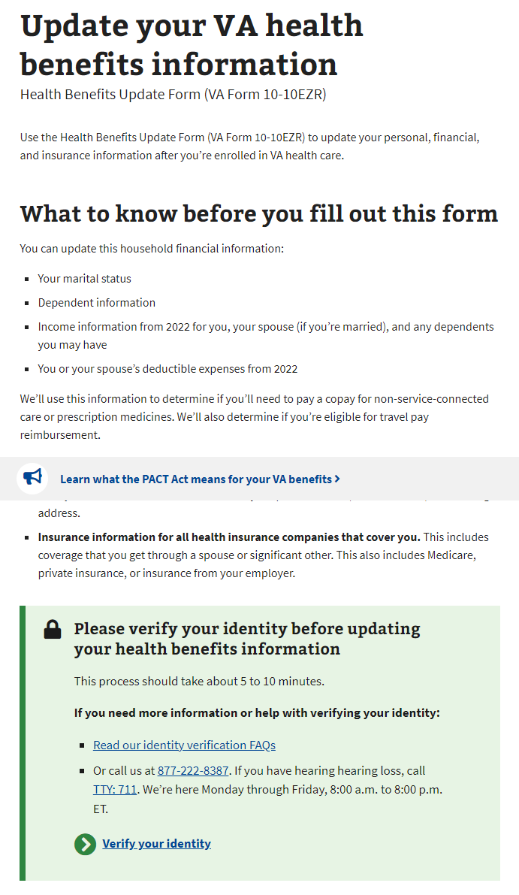

## Signed-in Users: LOA3 (Identity Verified)

For signed-in LOA3 users, we will automatically perform a scan on the backend for existing health care records in the enrollment system (ESR) when they go to the form introduction page at https://www.va.gov/my-health/update-benefits-information-form-10-10ezr/introduction

For users not found in the ESR, they will not be able to go straight into the Health Benefits Update form and instead will see a message advising them to apply for health care with a link to the Veteran health care application (10-10EZ):

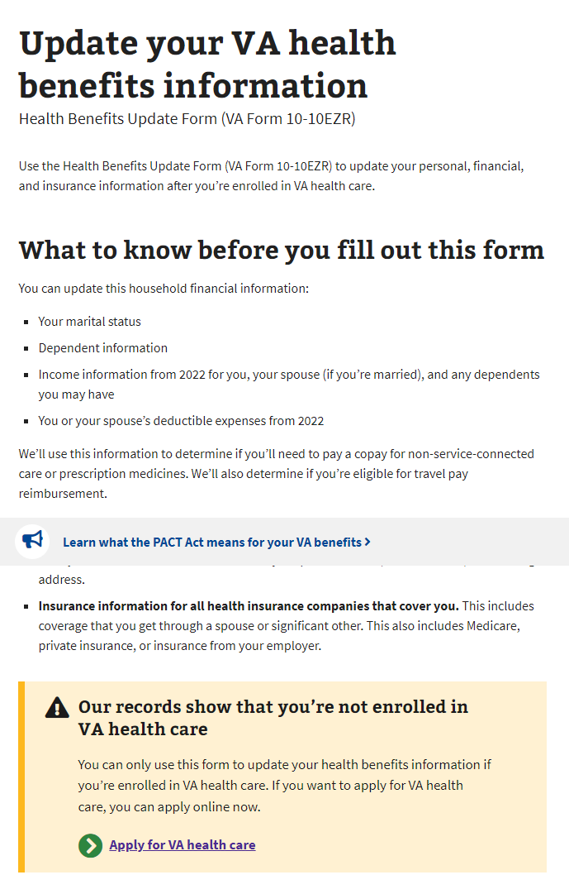

For users found in the ESR, they will fill out the Health Benefits Update form.

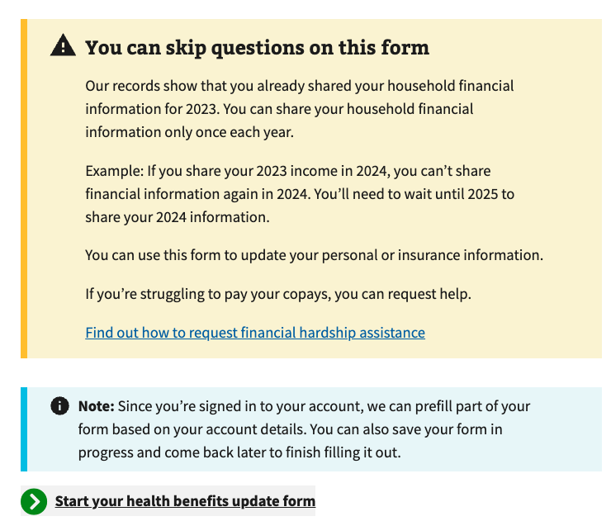

# Filling Out the Form

There are 5 sections in the Health Benefits Update Form:

1. Veteran information.
2. Military information (including toxic exposure)
3. Household information.
4. Insurance information.
5. Form review.

Note: The system will prefill some of the information on file. Users can review and update some of this information as they complete the form.

Each section has multiple pages of questions that the user must enter to complete the form. The form automatically saves as the user progresses, and they can “Finish this form later” if they choose.

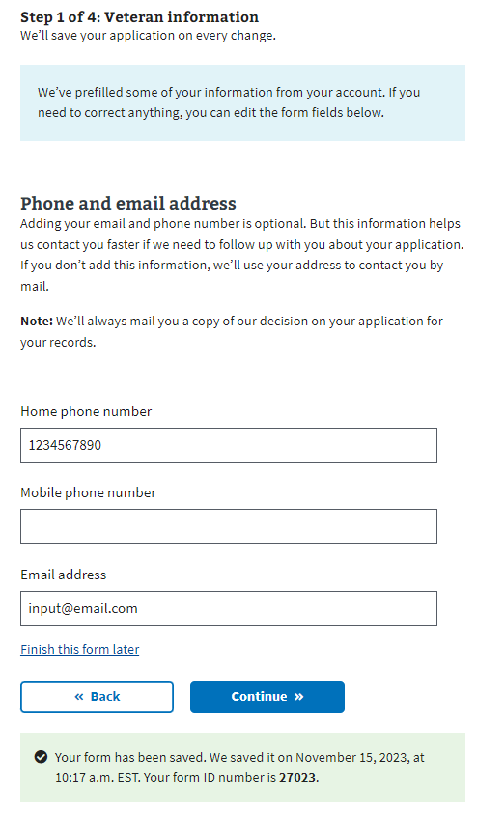

To move forward through the form, the user clicks “Continue.” They cannot move forward until all required information on the page is complete. An example error message is shown below. To go back to a section of the form, the user can use the back button.

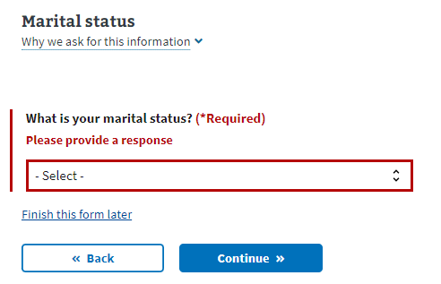

The form also has a status bar at the top of each page to indicate how far along a Veteran is in the form. It progresses when a new section is complete, not based on the number of questions completed:

## 

## Veteran Information

### Step 1 of 5: Names

Users are shown their name, DOB, and Social Security number in a locked state. If they need to update this information, they must contact the VA Benefits Hotline at 1-800-827-1000.

Authenticated User

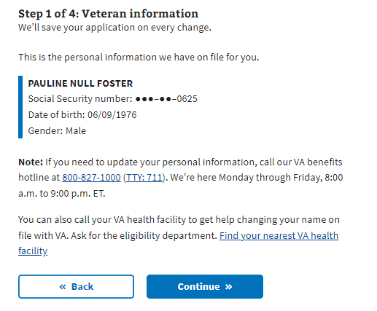

### Step 1 of 5: Mailing Address

If the user indicates that their mailing address is different from their home address, they must enter their home address on the following page.

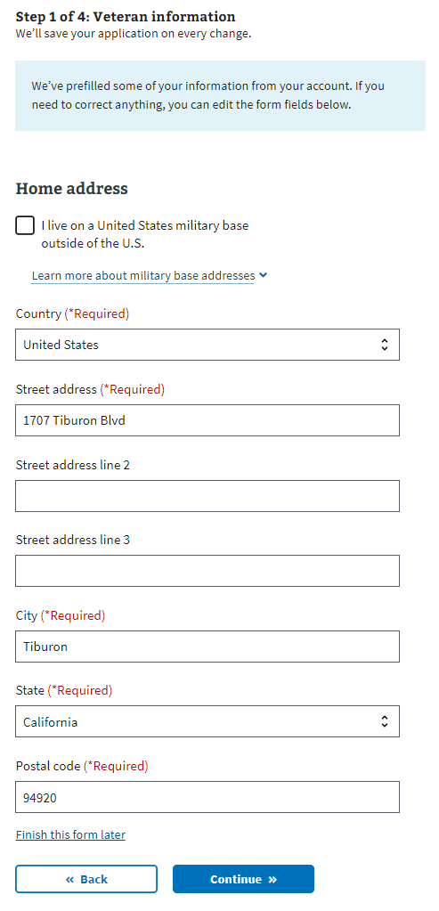

### Step 1 of 5: Phone and Email

Users may provide their email addresses and home/mobile telephone numbers. If the user shares this information, VA uses it to communicate with the Veteran during the form process. If they don’t provide either, correspondence is sent via postal mail.

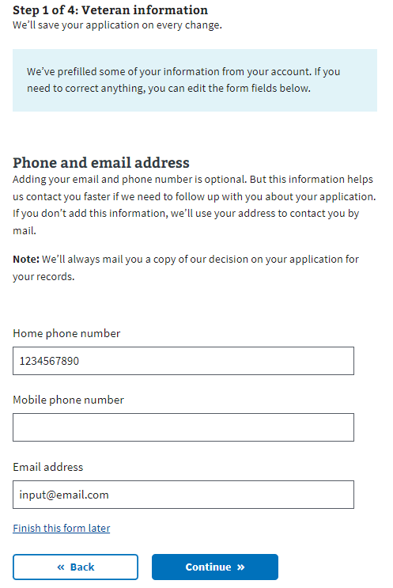Military Information

### 

### Step 2 of 5: Military Service

Military Service: Page 1

This page explains toxic exposure and provides resources users might want to access to learn more. A user can choose whether or not to answer questions regarding military service history and any toxic exposure (or potential toxic exposure). The following questions address specific locations, operations, and toxins associated with potential Veteran exposure.

## 

### Military service page 2: Cleanup or response efforts

Users can indicate whether they participated in any cleanup or response efforts on this page.

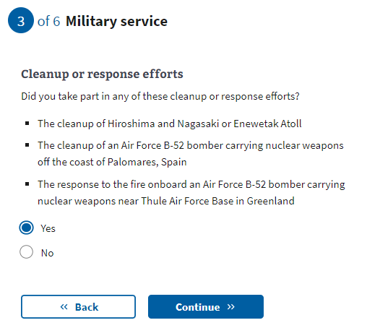

Military service page 3: Service in Gulf War locations

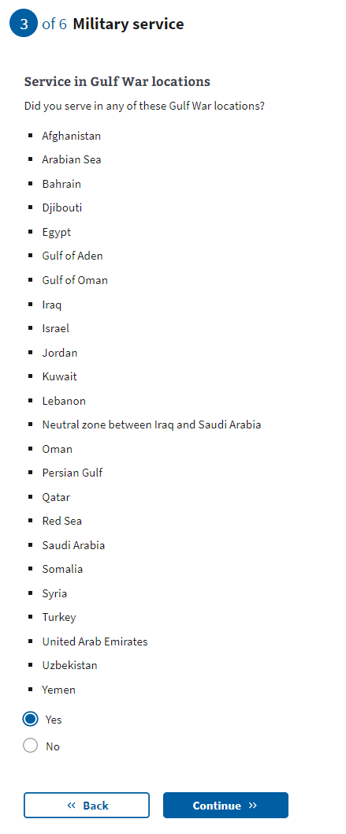

[Military service page 4:](https://docs.google.com/document/d/1q11ictK4zNJR4xZSBCcdndDI_PTItqzqFKfw8N3c1cA/edit?pli=1#bookmark=id.19c6y18) Service dates for Gulf War locations

These date fields are optional. If they know this information, users can provide a month, year, or date range. If the user does not know or does not want to estimate a date or range, they can leave these optional fields blank and continue to the next page.

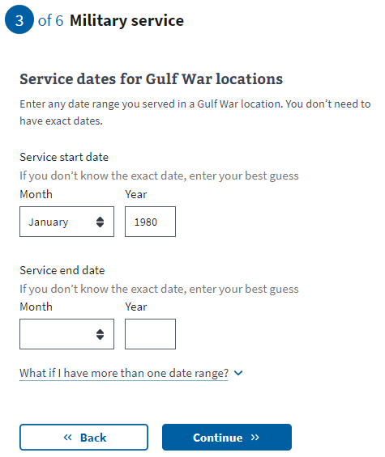

[Military service page 5:](https://docs.google.com/document/d/1q11ictK4zNJR4xZSBCcdndDI_PTItqzqFKfw8N3c1cA/edit?pli=1#bookmark=id.19c6y18) Operations

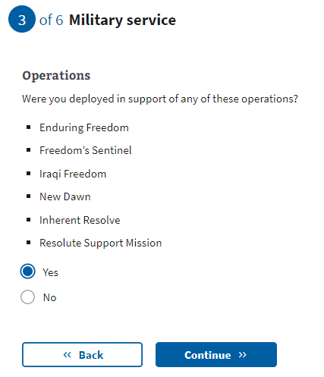

[Military service page 6:](https://docs.google.com/document/d/1q11ictK4zNJR4xZSBCcdndDI_PTItqzqFKfw8N3c1cA/edit?pli=1#bookmark=id.19c6y18) Agent Orange locations

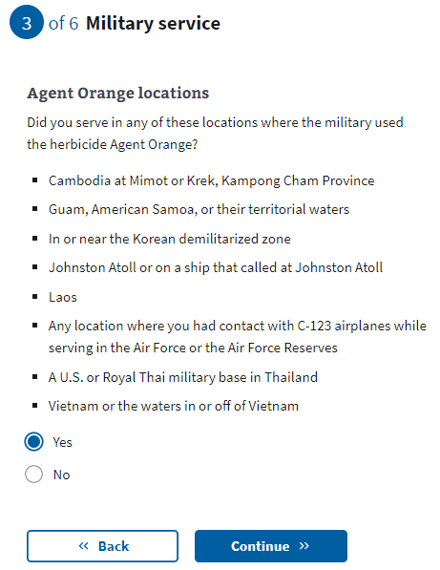

[Military service page 7:](https://docs.google.com/document/d/1q11ictK4zNJR4xZSBCcdndDI_PTItqzqFKfw8N3c1cA/edit?pli=1#bookmark=id.19c6y18) Other toxic exposures

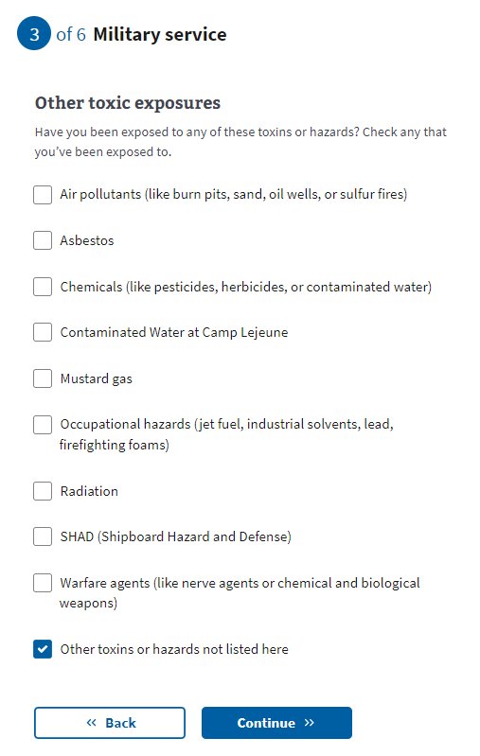

[Military service page 8: Other unlisted toxic](https://docs.google.com/document/d/1q11ictK4zNJR4xZSBCcdndDI_PTItqzqFKfw8N3c1cA/edit?pli=1#bookmark=id.19c6y18) exposure

If the user selects “Other toxins or hazards not listed here” from the previous question, they will be asked to list the toxin(s) to which they may have experienced exposure.

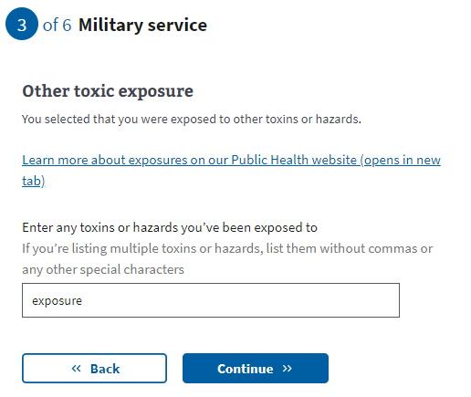

[Military service page 9: Dates of](https://docs.google.com/document/d/1q11ictK4zNJR4xZSBCcdndDI_PTItqzqFKfw8N3c1cA/edit?pli=1#bookmark=id.19c6y18) exposure

These date fields are optional. If they know this information, users can provide a month, year, or date range. If the user does not know or does not want to estimate a date or range, they can leave these optional fields blank and continue to the next page.

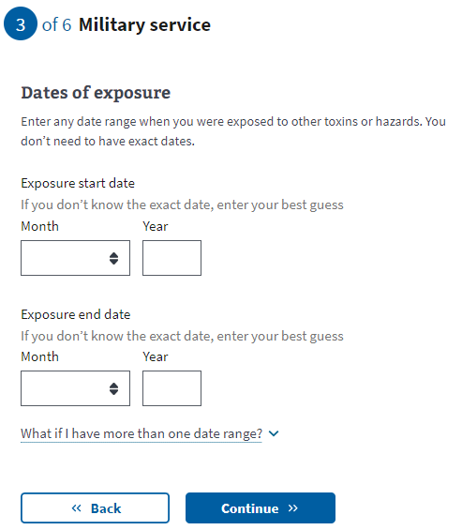

## Household Information

### 

### Step 3 of 5: Marital status

The user will now need to indicate their marital status from the drop-down.

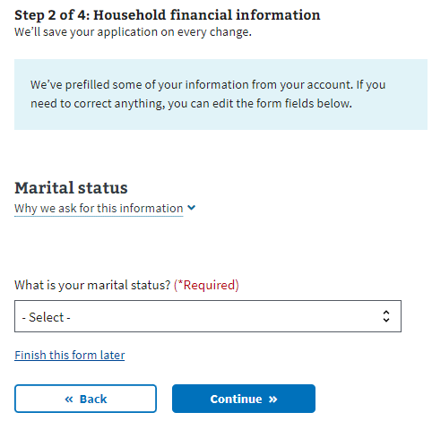

### Step 3 of 5: Spouse’s personal information

If the Veteran has indicated they are married or separated, they must fill out their spouse’s information.

They must complete the insurance information section next if they have indicated that they have never been married, divorced, or widowed.

### 

### Step 3 of 5: Spouse’s additional information

The Veteran must specify whether their spouse lived with them during the previous year and whether they live with them now. This information will help determine whether the spouse should be considered a dependent.

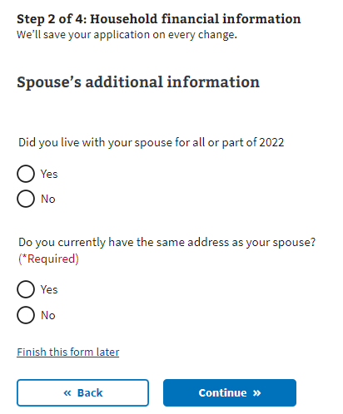

### Step 3 of 5: Spouse’s financial support

If the Veteran indicates that they did not live with their spouse the previous year, they must specify whether they provided financial support to their spouse.

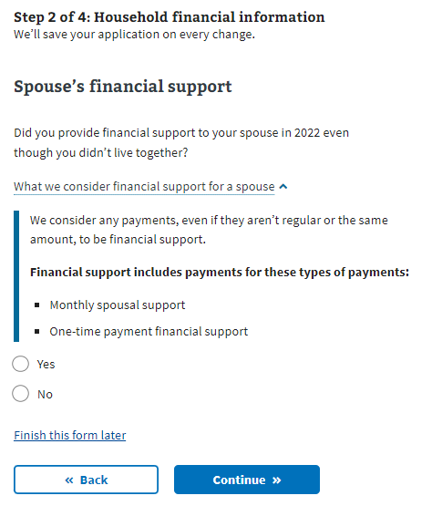

### Step 3 of 5: Dependent’s information

If the Veteran wants to add their dependent, the form will ask them to input information about that person. They will have the option to enter more than one dependent.

Examples of when someone becomes your dependent:

* **Birth of a child**: The DOB would be the date the child became your dependent.
* **Adoption**: The official date of adoption would be the date on which the child became your dependent.

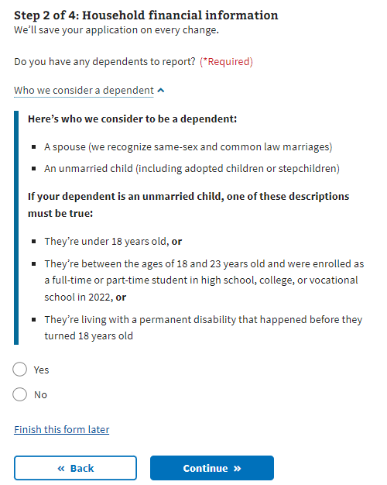

### Step 3 of 5: Dependent’s personal information The Veteran must provide the dependent’s information. All required fields must be completed before saving the form. If the Veteran exits before completing the necessary fields for the dependent, the form won’t save, and they’ll have to re-enter the data.

### 

### Step 3 of 5: Dependent’s education expenses

The Veteran must provide information on education expenses if the dependent is between 18 and 23.

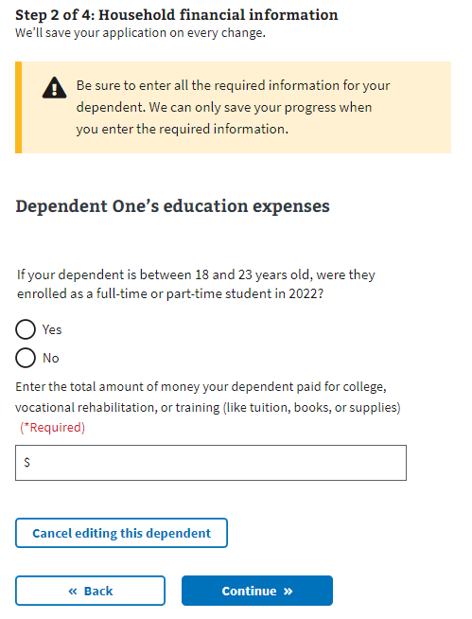

### Step 3 of 5: Dependent’s additional information

The Veteran must indicate whether their dependent was permanently disabled before turning 18, whether they lived with them during the previous year, and if the dependent earned any income during the last year.

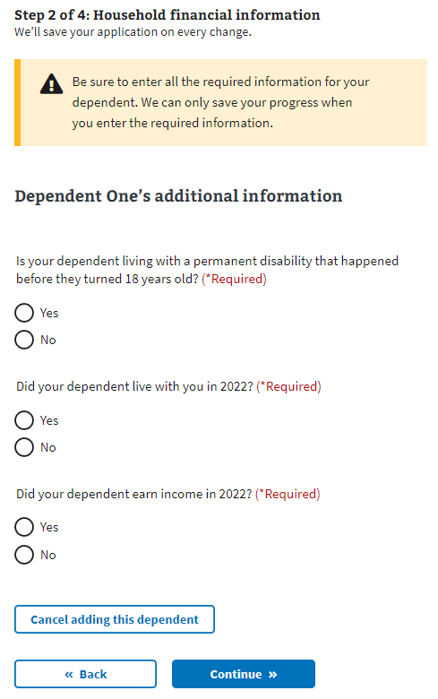

### Step 3 of 5: Dependent’s annual income (previous year)

If the Veteran indicates that their dependent earned income during the previous year, the form requires the income details.

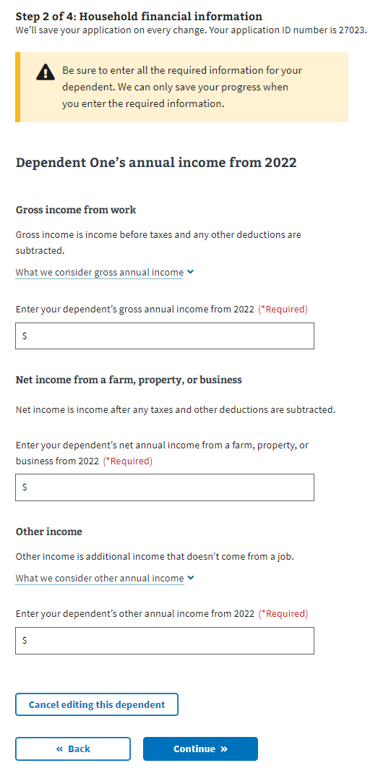

### Review Your Dependents

Once the user has entered at least one dependent, they will see their dependent listed and be able to edit or remove the information. The user can add dependents by answering “Yes” to “Do you have another dependent to report?”  
  
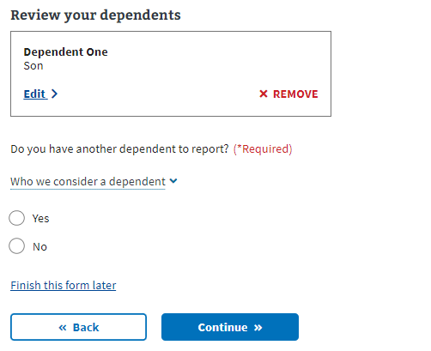

### Step 2 of 5: Annual income

The user must provide the requested financial information in the following forms. The form will ask about their annual income and the previous year’s deductible expenses. If the Veteran indicated they were married, they must also disclose their spouse’s annual income.

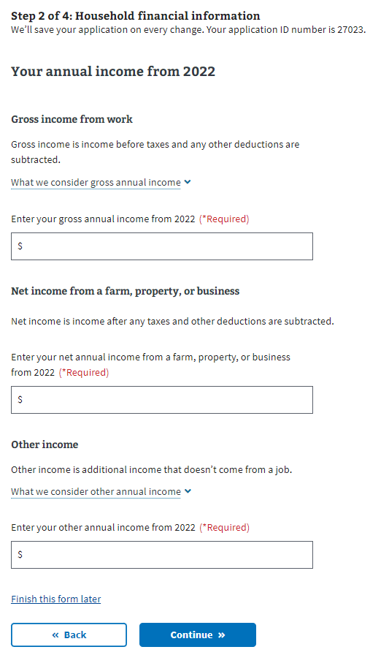

### Step 3 of 5: Previous calendar year’s deductible expenses

### 

## Insurance Information

### Step 4 of 5: Medicaid

All users view this page. The user needs to indicate whether they’re eligible for Medicaid.

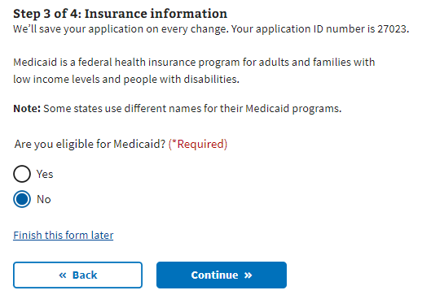

### Step 4 of 5: Medicare

If the user is enrolled in Medicare Part A, they must indicate so during this step. Selecting “Yes” sends the user to a page where they provide the effective date of their Medicare Part A coverage.

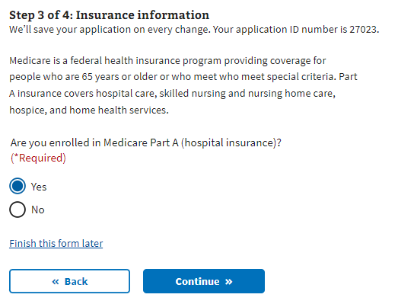

### Step 4 of 5: Medicare detail

The user is required to disclose the effective date of their Medicare Part A and Medicare claim number.  
  
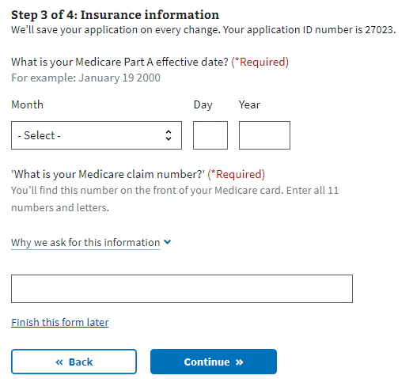

### Step 4 of 5: Other coverage

The user needs to indicate whether they have any additional health insurance coverage. If they do, the user must select “Continue” to proceed to the next page and input that information.

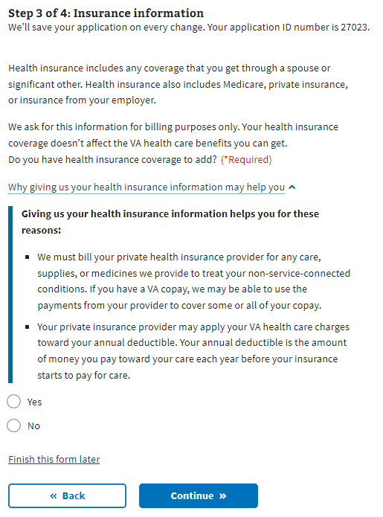

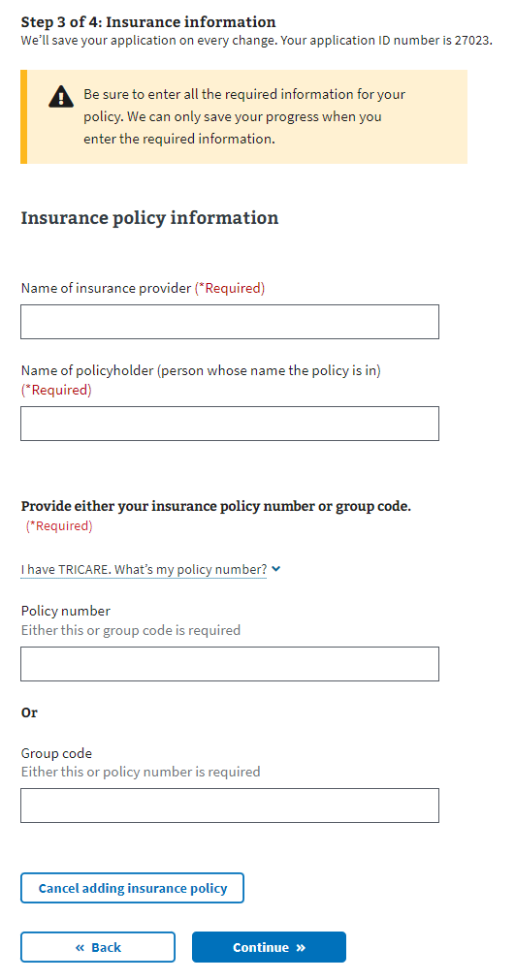

Once the user has entered at least one insurance policy, they will see their insurance policy listed and can edit or remove the information. They will have the option to enter more than one insurance policy.

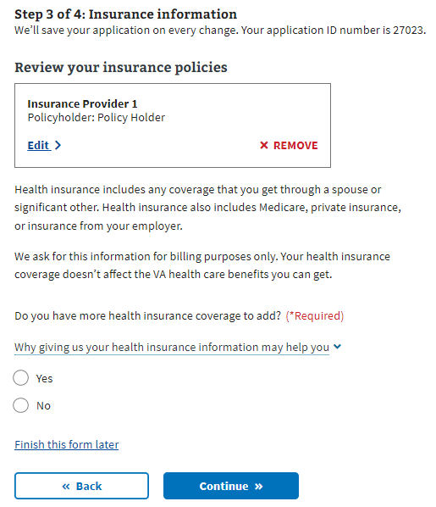

## Step 5 of 5: Review

Once the Veteran has completed the form, they will see the Review step, where they can open each section and see what information they entered.

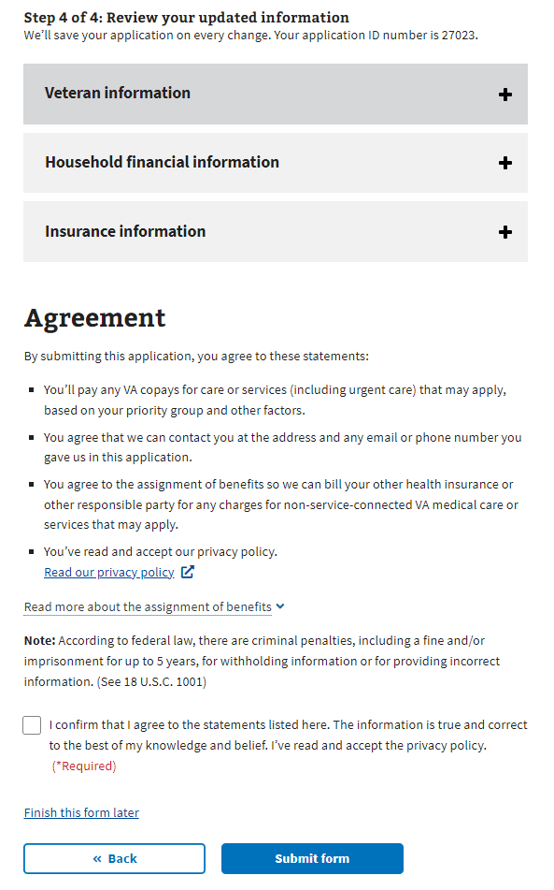

If they want to change the information shown, they can select the “Edit”button and change that information.

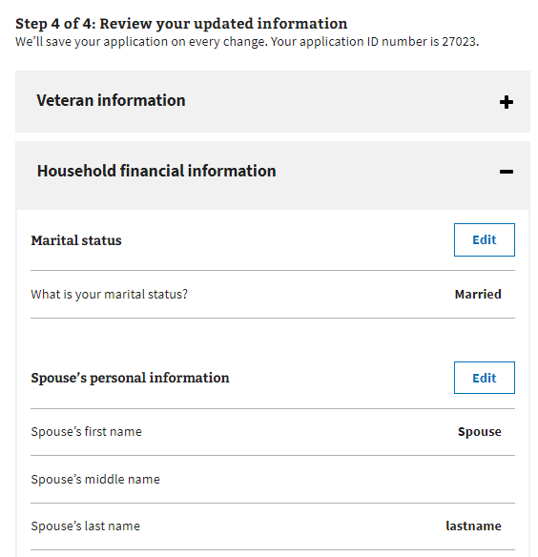

Once the user presses the “Edit” button, they can update their information. They must press the “Update Page” button to save the changed data.

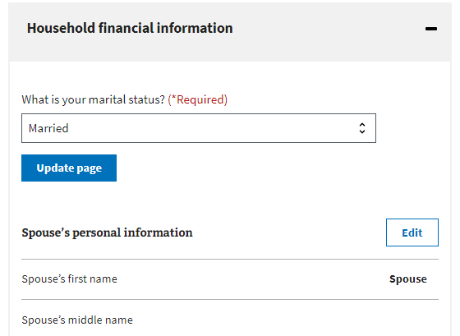

If any changes are made to remove required information or trigger additional questions, the form will draw the user’s attention to where updates are needed.

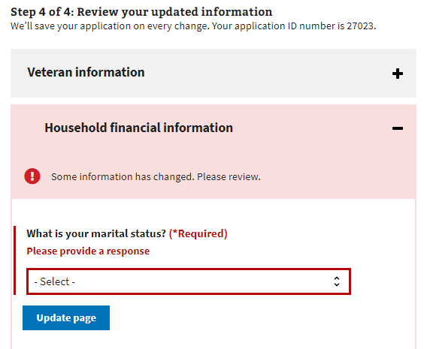

Once the user has reviewed the information and is ready to submit the form, they must select the check box indicating they agree to the statements listed, that the information is accurate, and that they have read and accepted the privacy policy. The privacy policy is accessible via a link to a new tab; their form won’t be interrupted.

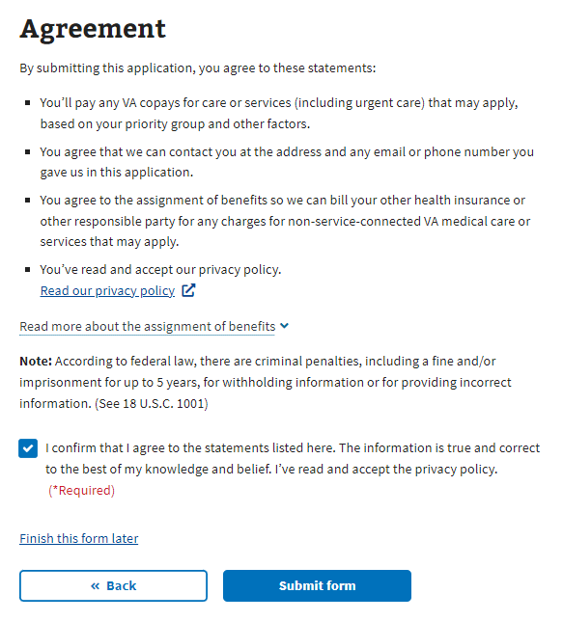

After the form is submitted, the user sees the following:

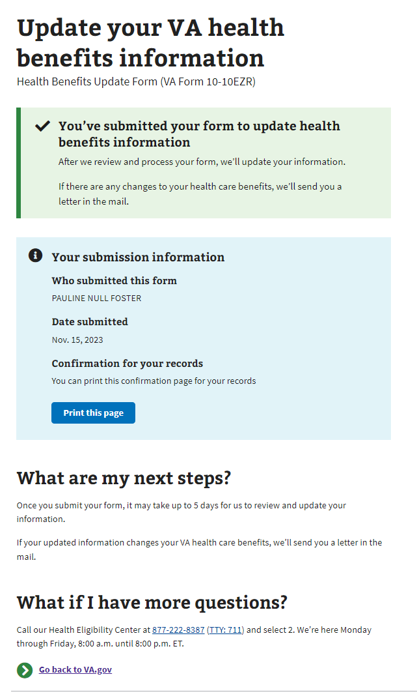

# Health Benefits Update Form Troubleshooting

## Questions About the Content of the Form

Many Veterans will have specific questions about the content of the form because they don’t understand what the form is asking or why it needs that information. The Health Enrollment Center (HEC) should know these non-technical issues. Before transferring the Veteran to this call center, ensure they don’t have any questions related to the navigation or issues entering information for technical reasons.

The information for the HEC is at the bottom of every page in the Health Benefits Update Form:

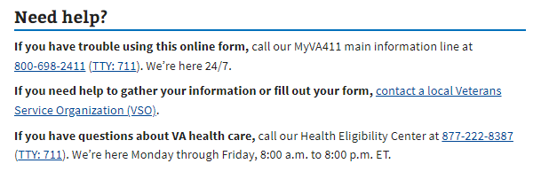

## The Form is Prefilled With Incorrect Information

If a Veteran has already entered information about themselves or their account has personal, contact, or spouse information associated with it, that information should populate the form. The purpose is to make it easier for the Veteran to complete the form. However, if the data needs to be corrected, it may need to be clarified for the Veteran. They can fix this by editing the information in the form directly.

## Veteran Can’t Move Forward in Their Form

If a Veteran is saying they can’t move on to the next page in the form, ask them to verify that they have filled out all the required information. The website will display red text indicating where necessary information is missing:  
  
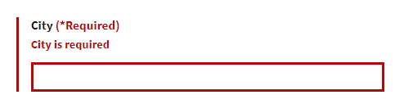

## The Veteran is Having Trouble Upgrading From LOA1 to LOA3

If a Veteran is trying to apply for health care benefits with their LOA1 (not identity verified account), they will be required to upgrade to an LOA3 (identity verified) account. They can do this using ID.me, Login.gov, or an upgraded My HealtheVet or DS Logon account. If the Veteran prefers not to do this, they can update their information over the phone or in person at their local VA facility.